Dear Palmer Park Preparatory Academy Parents, Teachers, and Community Members,

On behalf of the Palmer Park Preparatory Academy (P3A) Parent Teacher Association (PTA), we are writing to welcome you to the 2023-2024 school year, to share our vision for the upcoming year, and to ask for your support in bringing our vision to fruition. We had an outstanding 2022-2023 school year at P3A! A few of our accomplishments included: working with the Greening of Detroit to plan over 20 trees on the P3A grounds, hosting the first annual silent auction, which raised over $8,000 for our PTA, and supporting a variety of school events like the Trunk or Treat party, End-of-Year Field day, and the 8th grade dance. Our role as a PTA is to build community, support and augment P3A initiatives, support and appreciate the P3A staff, provide feedback to the school, and to assist with long-term measures to sustain and improve our school. As we look towards the upcoming year, we want to build on what we did last year and accomplish even more.

To make our vision a reality, our top priority this year is getting more parents and teachers directly involved in the PTA. To make it as easy as possible to be involved, we are asking that every parent and teacher do the following:

1. Join our PTA and pay your dues.   |   2. Sign-up to volunteer for an event/activity this semester.
3. Complete the volunteer form for the district.   | 4. Attend a PTA meeting or other PTA event.  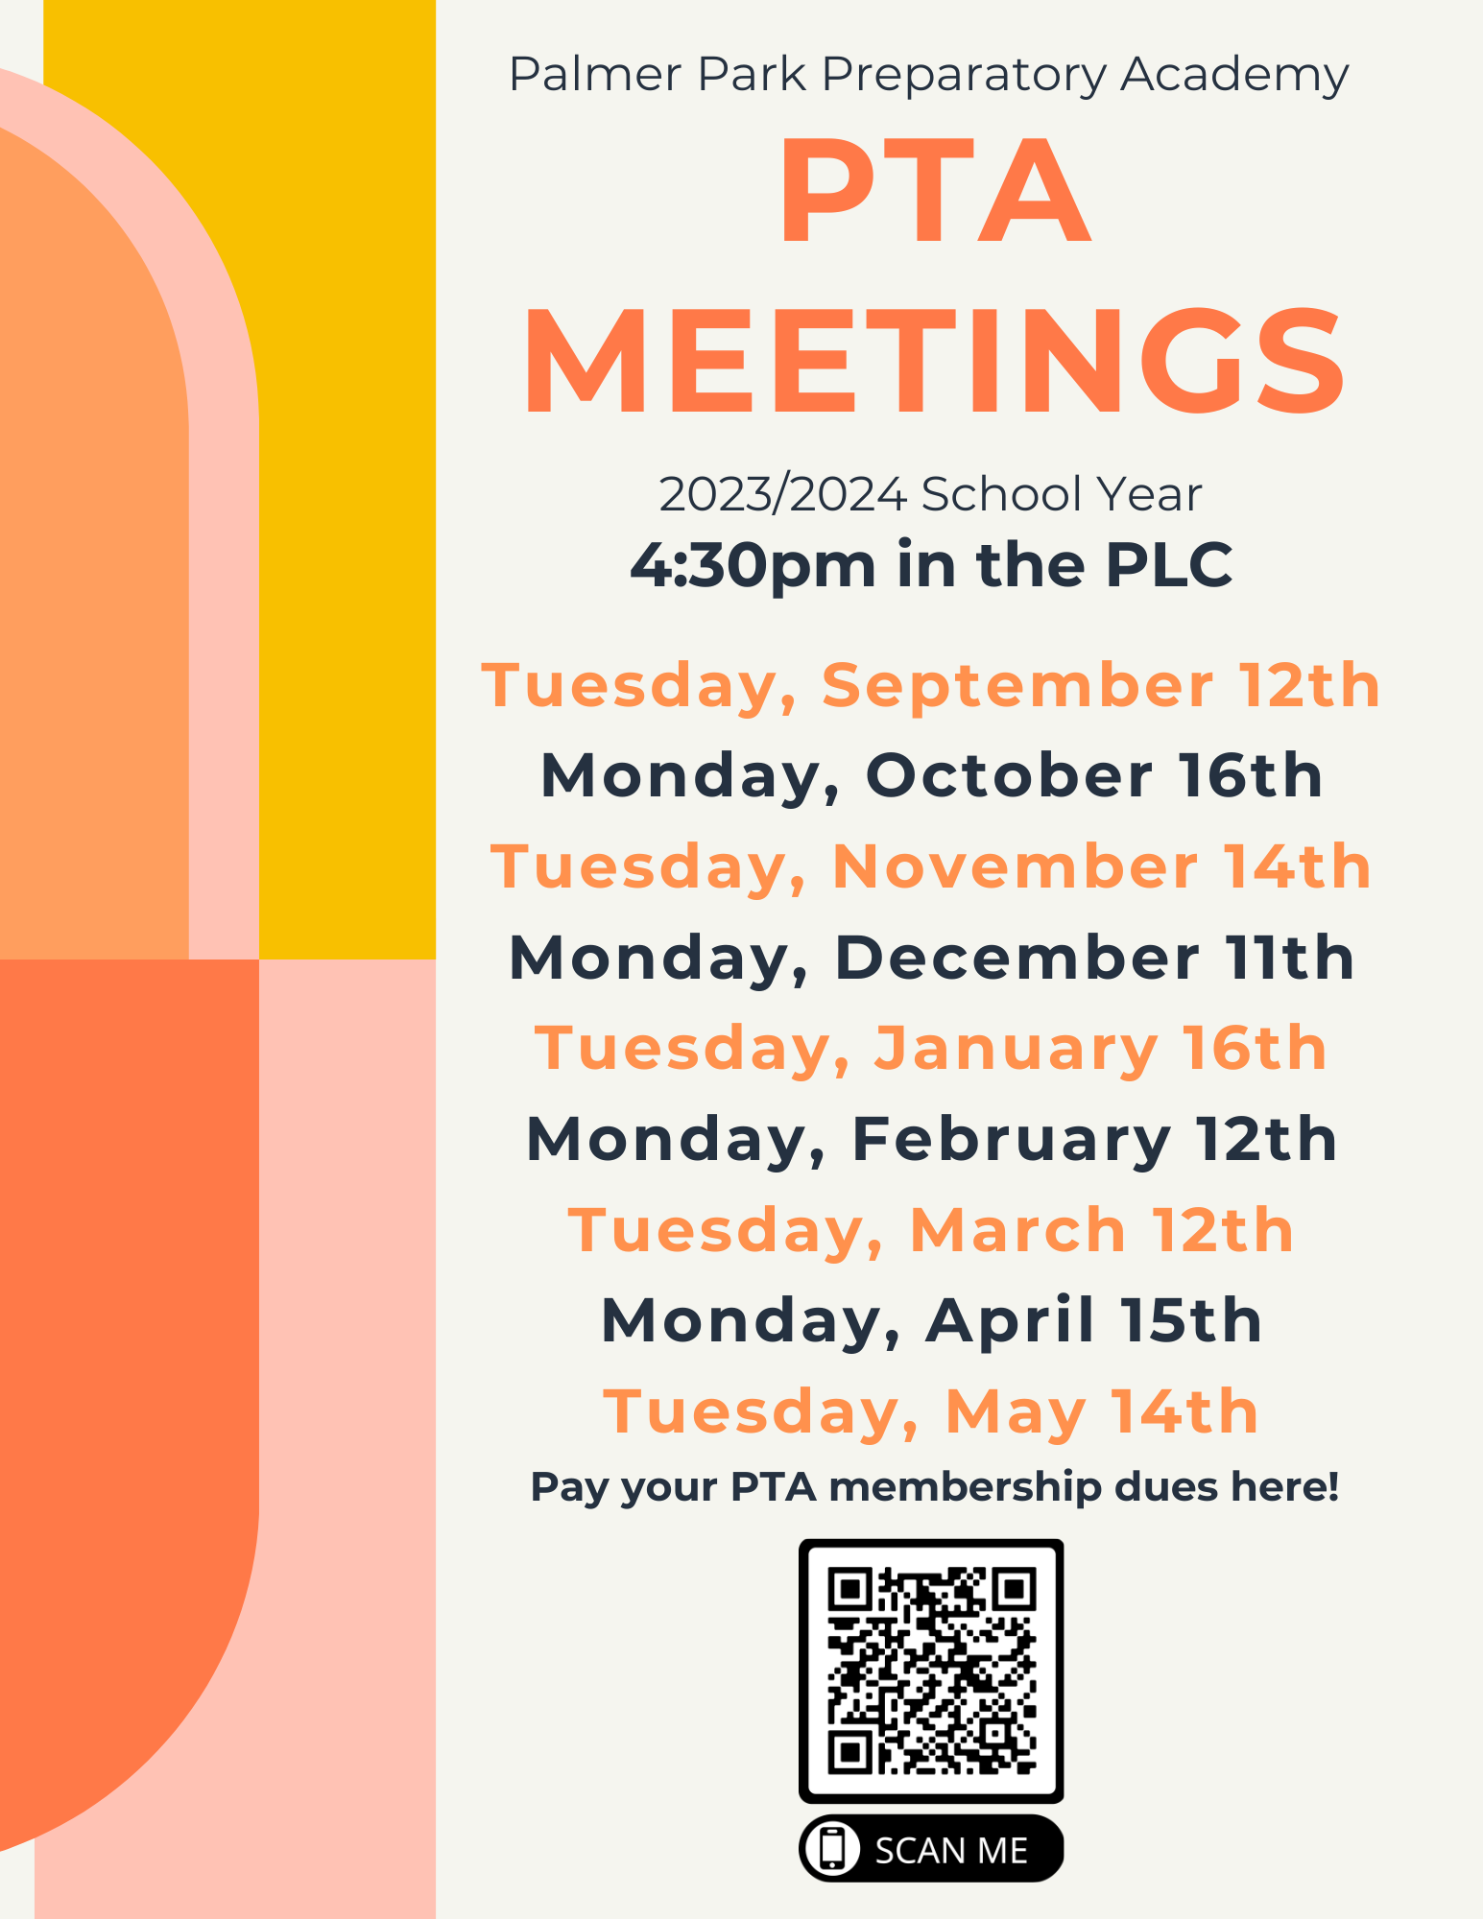

In addition to our PTA meeting on September 12th, we have several other events this month. On September 22nd, we are going to meet up after pickup on the playground from 4:00 - 6:00 pm. We will have donuts and cider and this will be a great chance to connect with other parents. On September 28th, we are going to have a P3A volunteer day, where parents can help teachers with classroom tasks or work outside tidying up the outdoor spaces. Parents can volunteer to attend or help lead these events using the SignUpGenius form above.
As the year progresses, expect to hear more information about various events and ways to volunteer. Most communications will come through our PTA Portal, Givebacks, and we will try to duplicate messages in our Facebook group as well as through Class Dojo. We also want you to know who the PTA Officers are in the event that you want to ask us questions, give us feedback, or just say “Hello”. The officers are:

  Brandy Mitchell  President  vopbrandy@gmail.com | 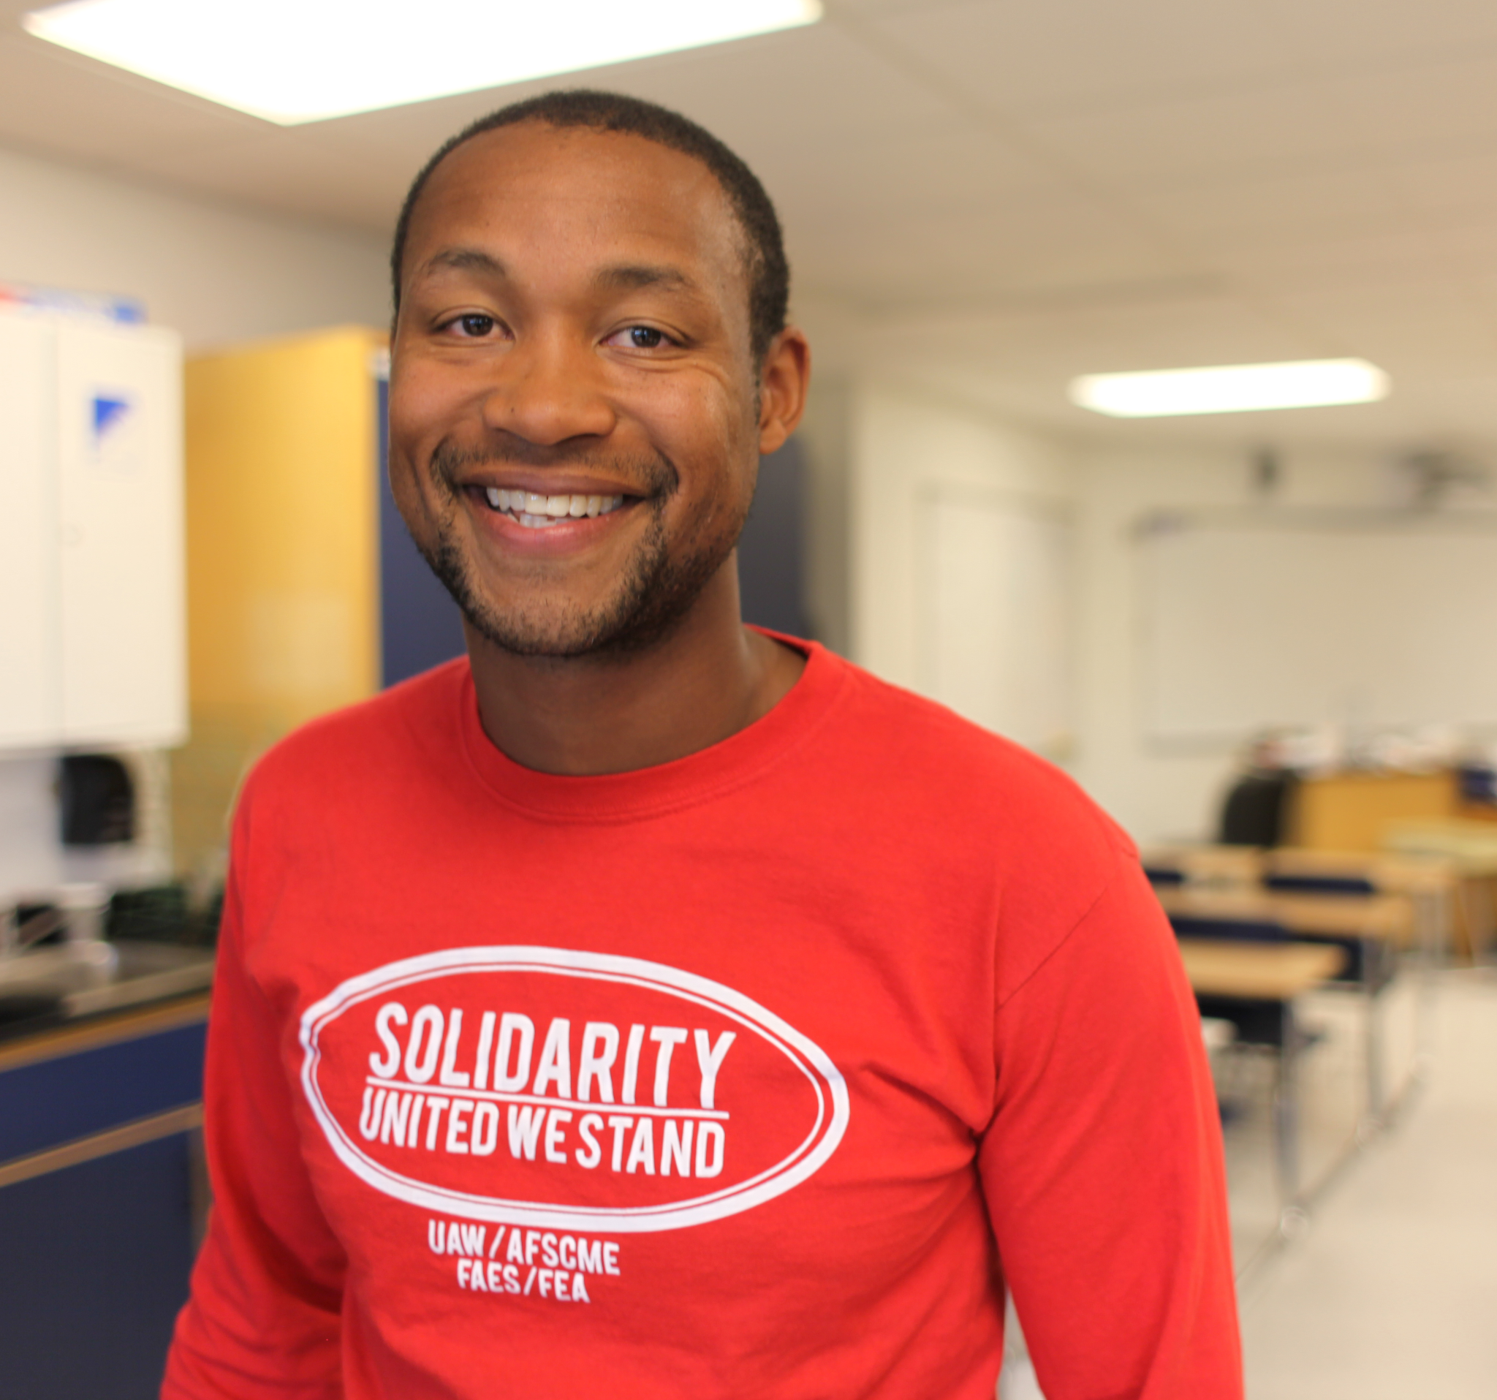  Maurice Telesford  Vice President  maurice.telesford@gmail.com
  Amelia Lee  Secretary  mrsamelialee@gmail.com | 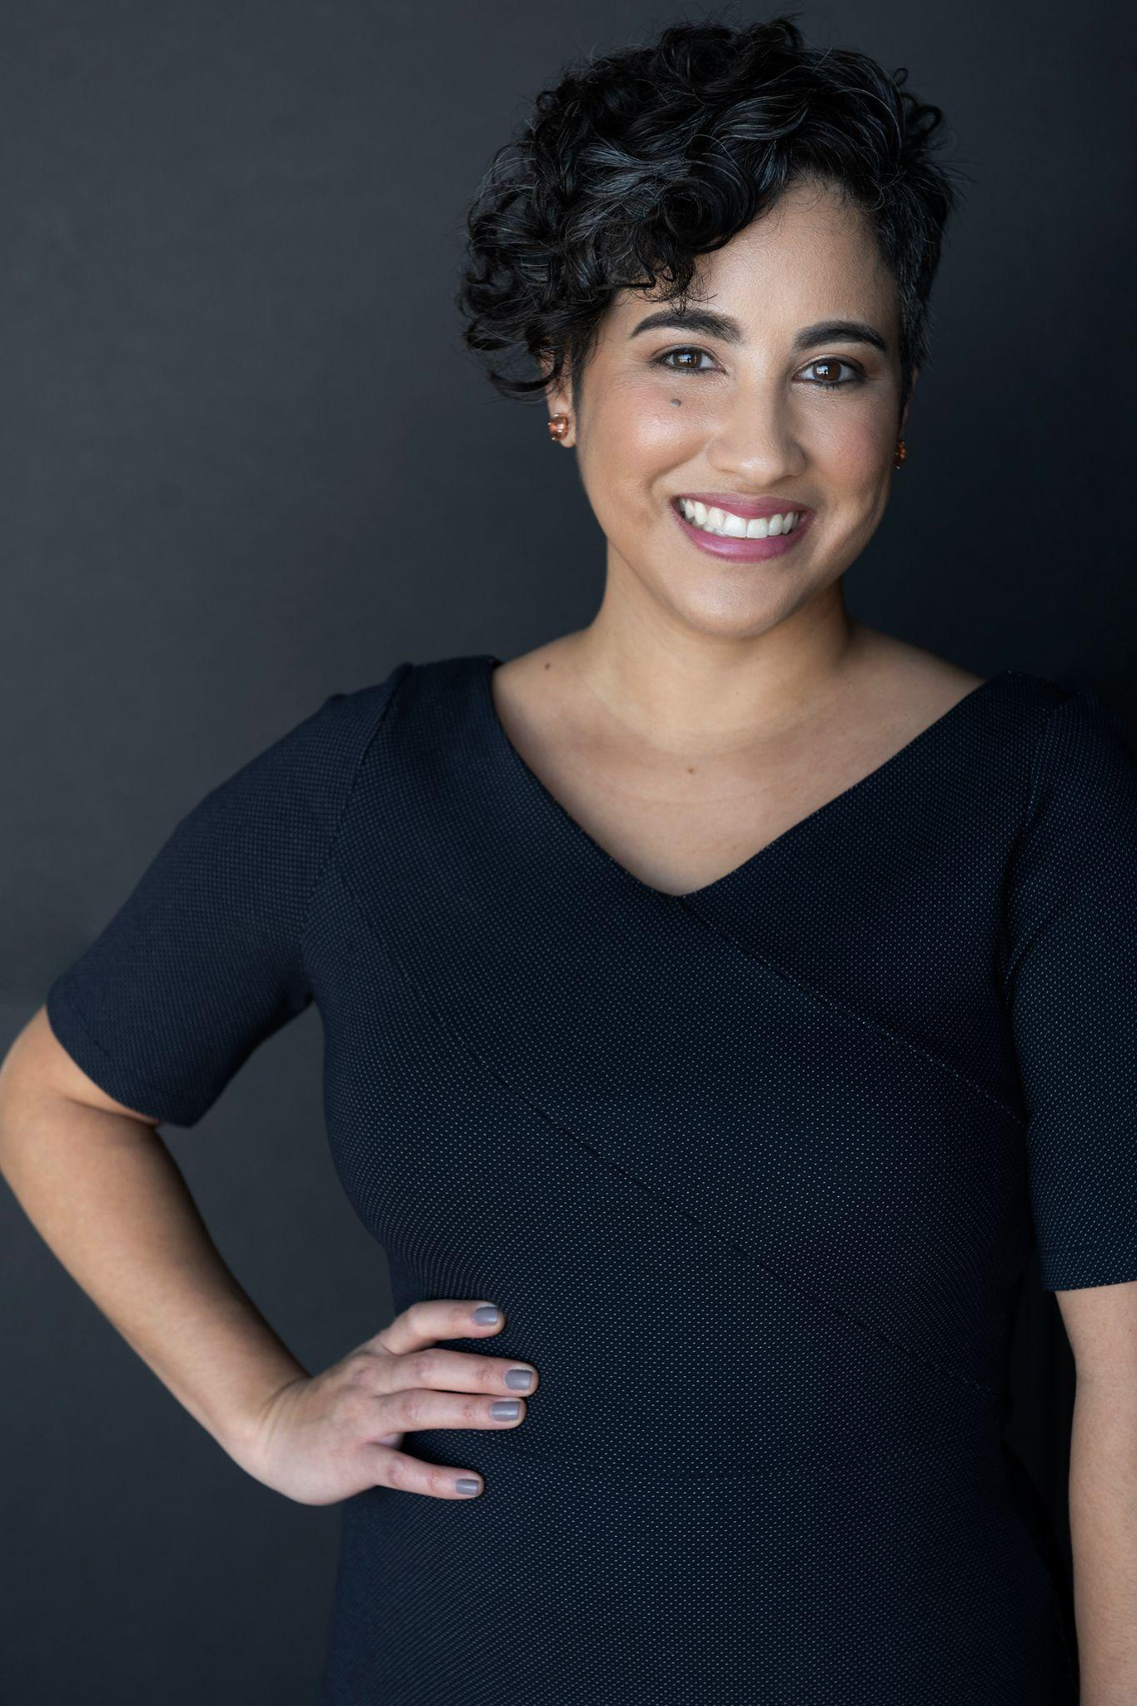  Mary Barton  Treasurer  marybartoncpa@gmail.com

In addition to our Executive Board, we have committees focused on beautifying and activating our outdoor spaces, fundraising, and coordinating volunteer efforts. If you have any interest in joining one of those committees, please let us know.
We hope that this welcome letter has been useful. As the old adage goes, “It takes a village to raise a child.” We feel honored to be a part of your village and to have you as a part of ours. We look forward to an outstanding year and hope that you will join us in our efforts to make the P3A PTA the strongest in the City of Detroit and beyond.

Sincerely,

P3A PTA Executive Board

